38] **cut –complement –c 1,5 f3**

This command shows the complementry of the data mentioned mean we mentioned 1 and 5 which wont be printed in the display remaning data is displayed

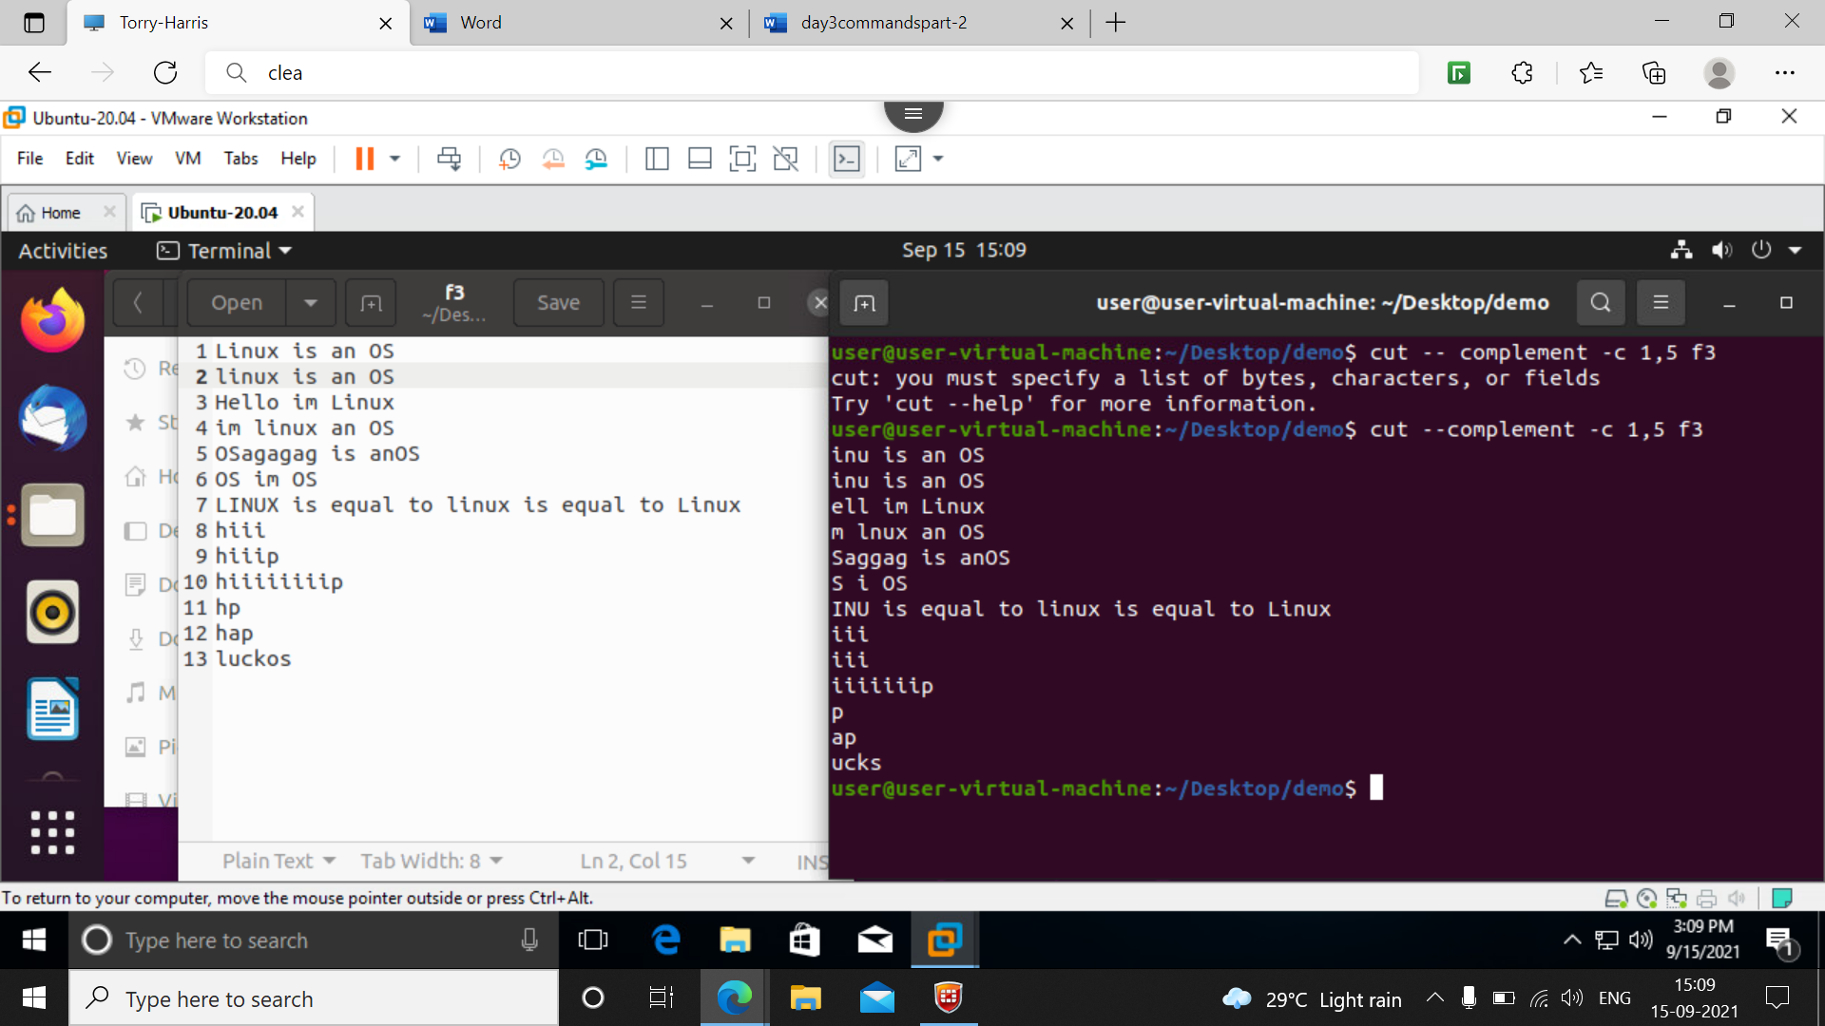

39] **cut –complement –c 4- f3**

This means the data of 1,2,3 column should be displayed and after 4th col it stops

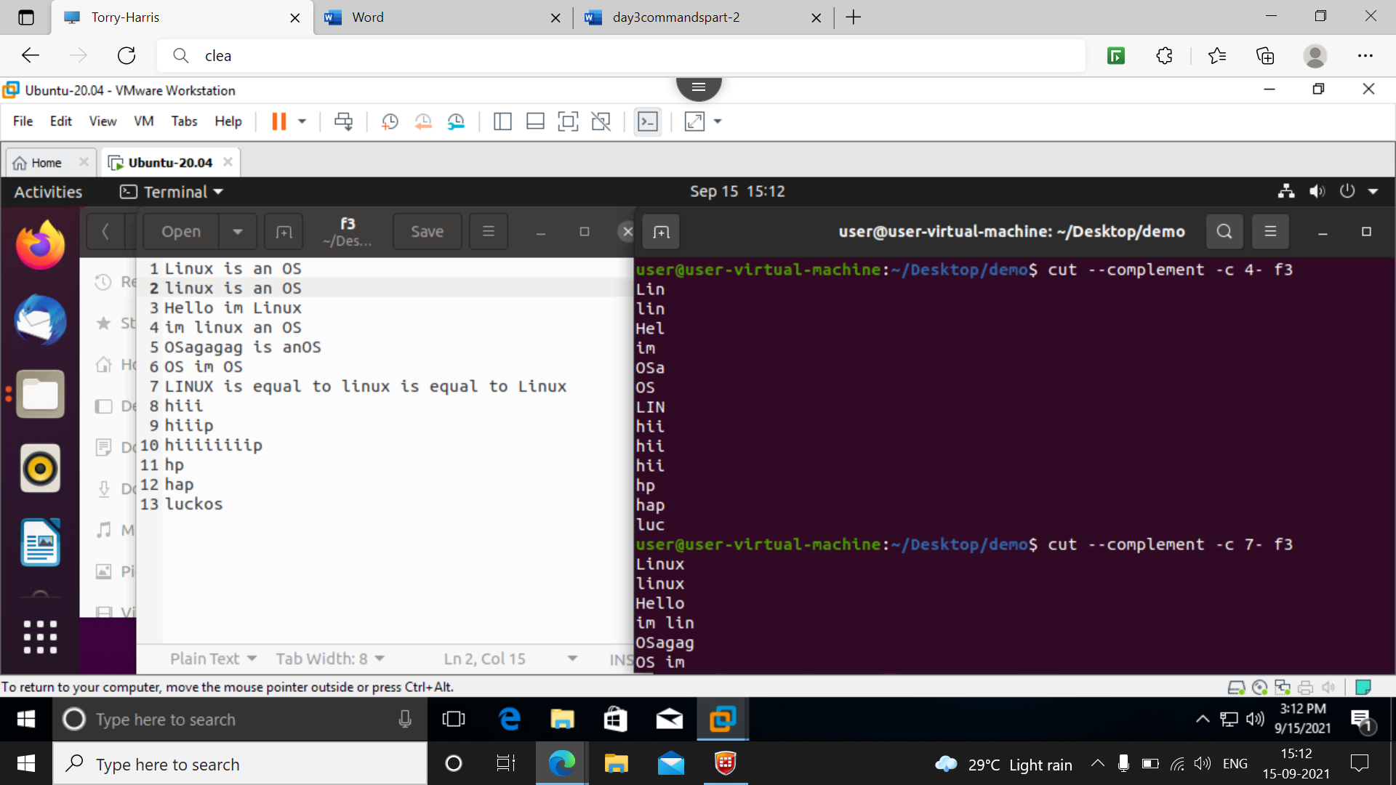

40] **cut –complement –d ‘ ‘ -f 2 f3**

It Is a complement command we defined a delimeter at 2nd space the value at 2nd space is not printed remaining data is printed

Similarly if I give for 3rd space it wont display for 3rd space

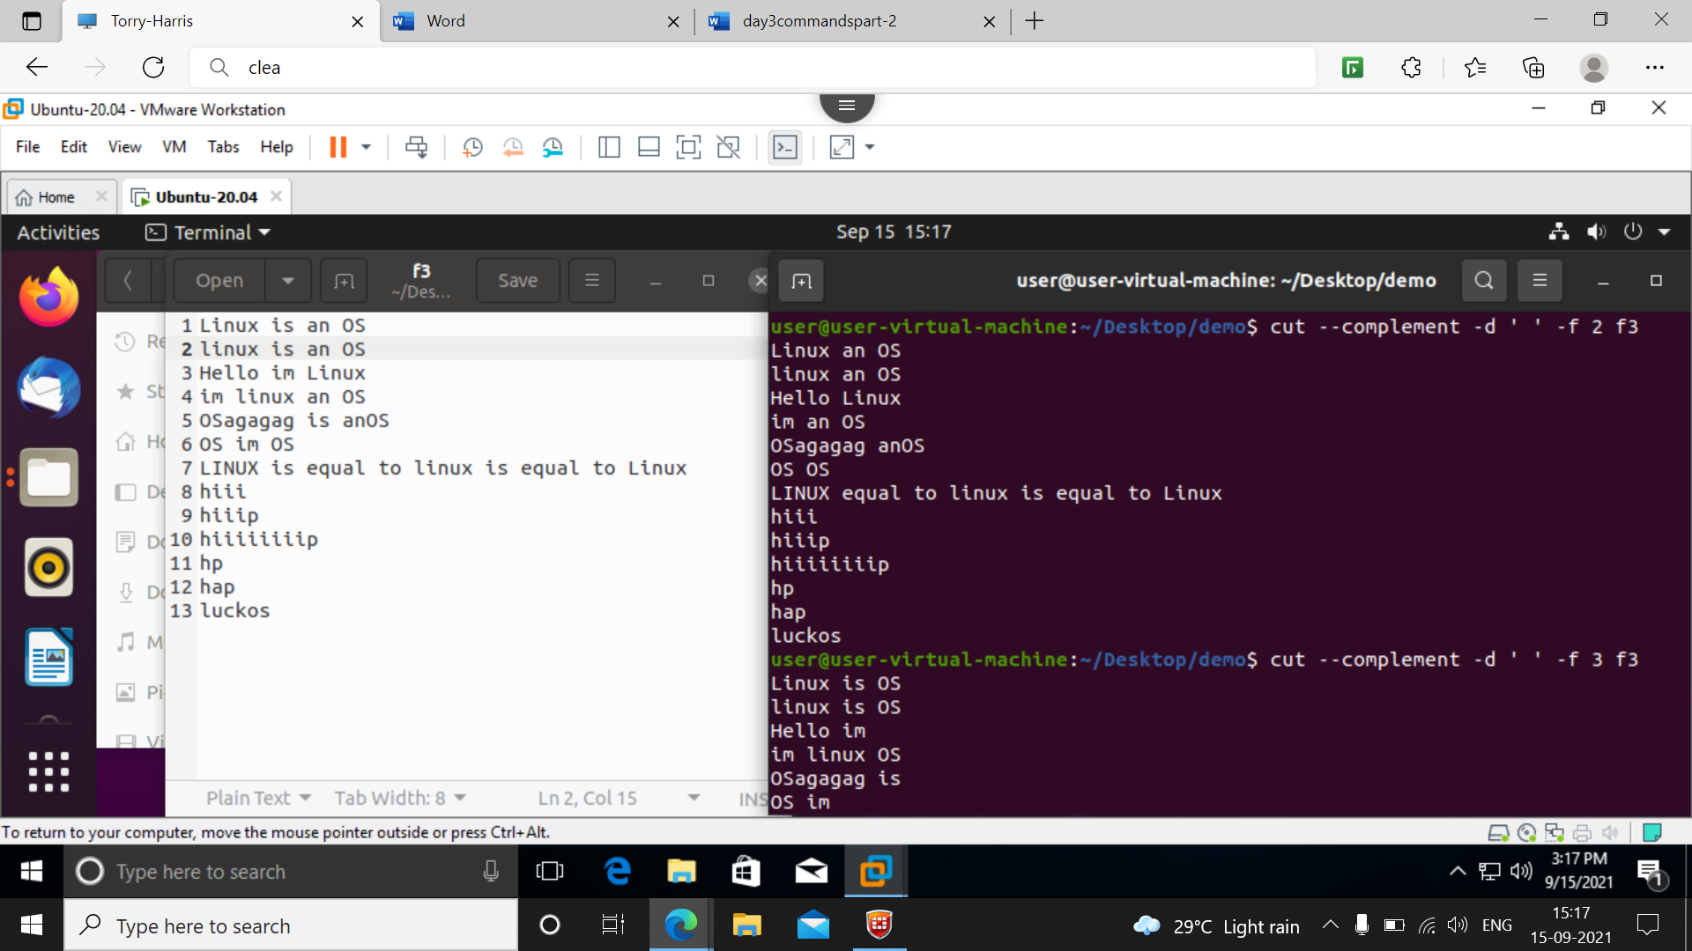

41] **cat f3 | cut –d ‘ ‘ -f 1 | sort**

**T**o sort the given data till the 1st space as defined

42] **cat f3 | cut –d ‘ ‘ -f 1 | sort –r**

To sort the data in reverse order

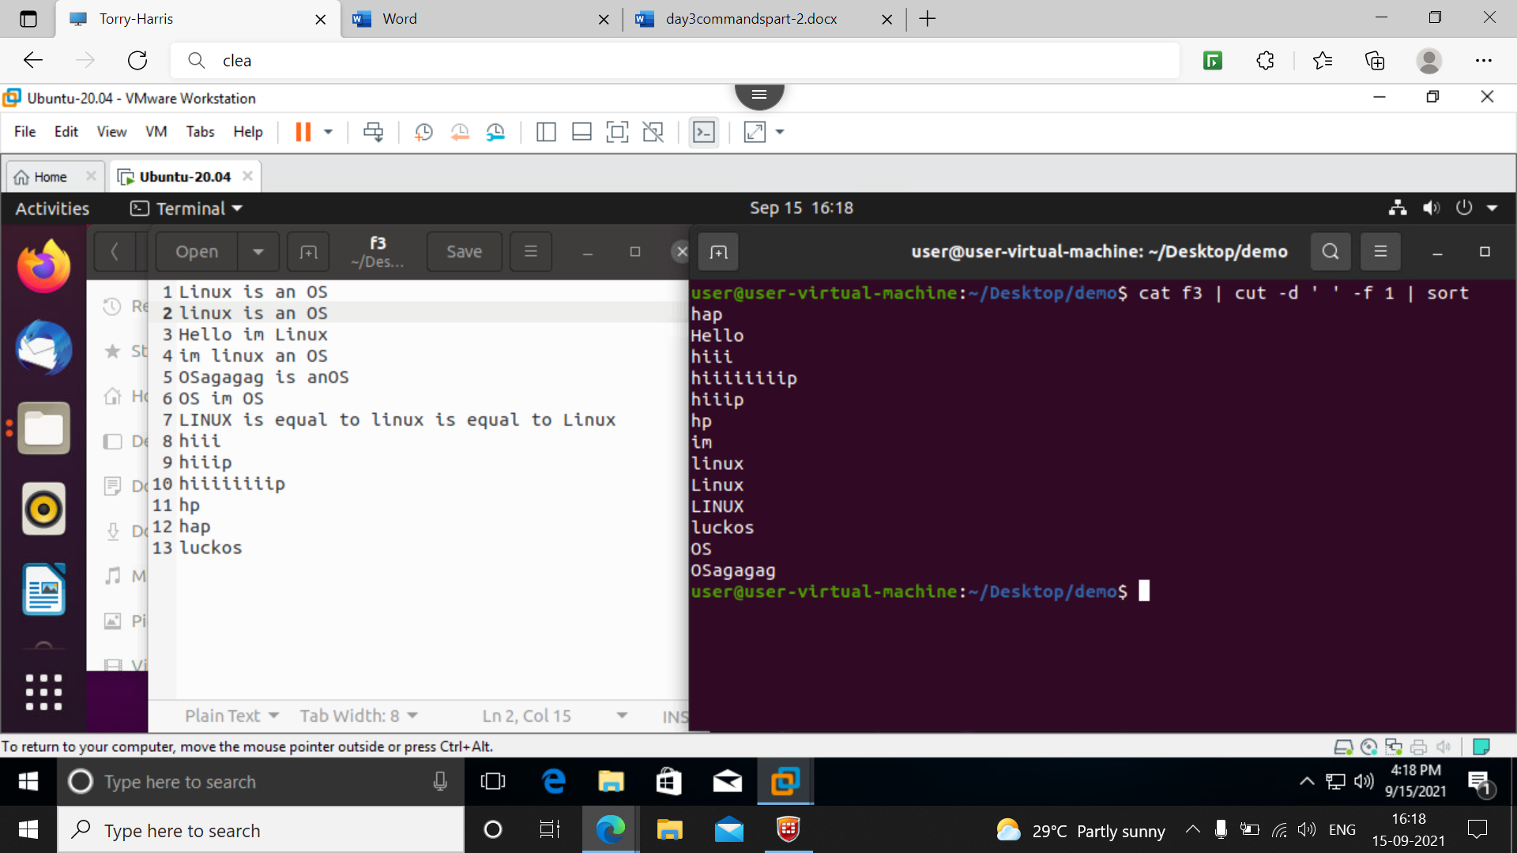

**43] cat f3 | tr ‘[a-z]’ ‘[A-Z'] or**

**cat f3 | tr ‘[:lower:]’ ‘[:upper:]’**

This command convert the data in f3 from low to upper alphabets as shown below

**44] cat f3 | tr ‘[A-Z]’ ‘[a-z'] or**

**cat f3 | tr ‘[:upper:]’ ‘[:lower:]’**

This command convert the data in f3 from upper to lower alphabets as shown *below sceenshot*

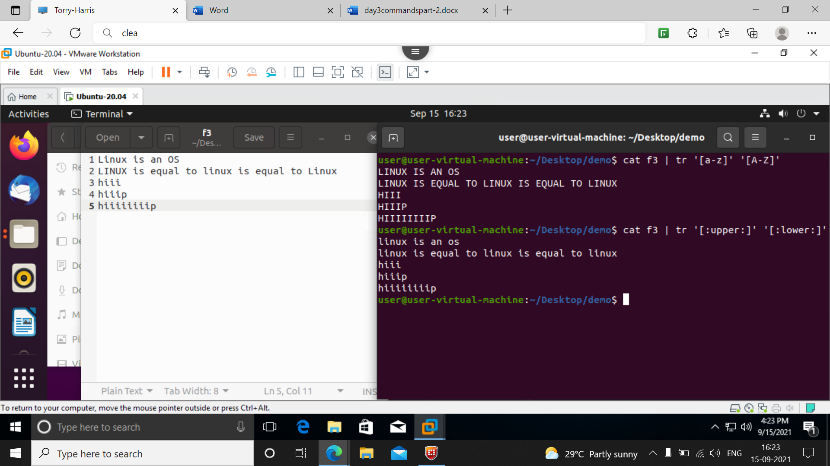

**45] cat f3 | tr ‘[:space:] ‘\n’**

This command in f3 file whenever hits a space it comes to new line.

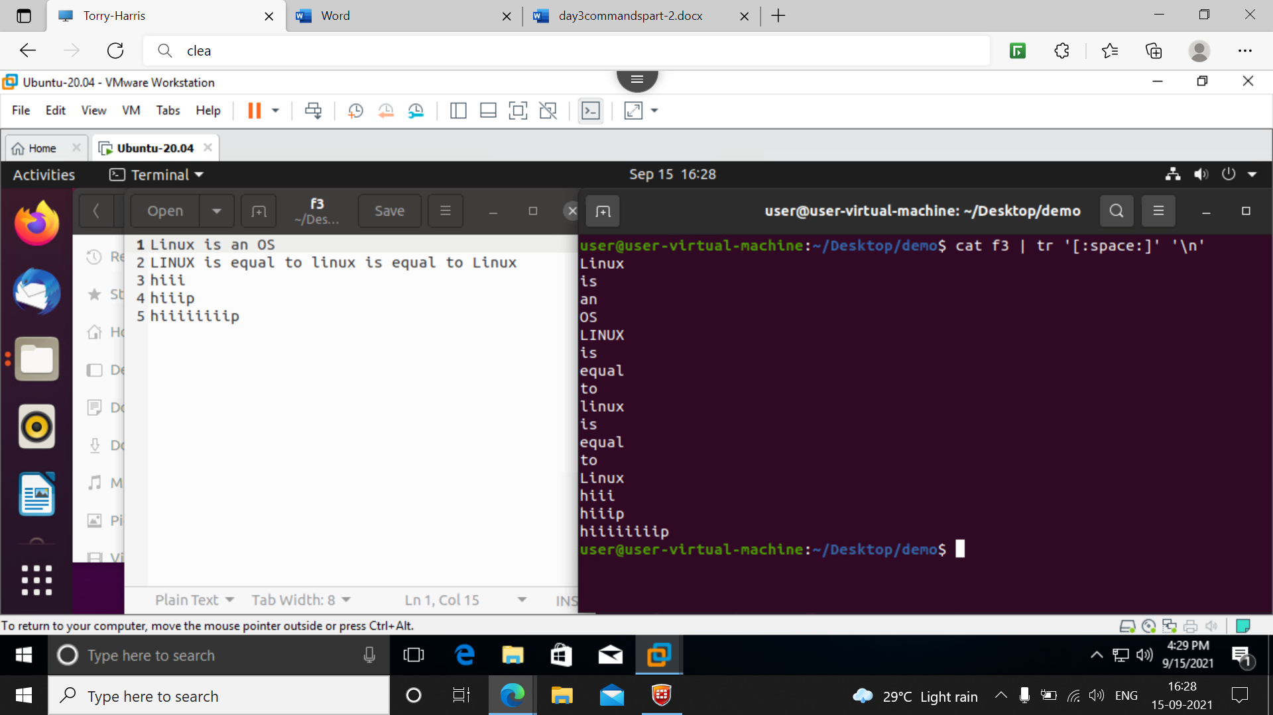

**46] cat f3 | tr ‘h’ ‘k’**

This command tells in f3 file the ‘h’ character to be changed to ‘k’ the op is shown in sceeenshot

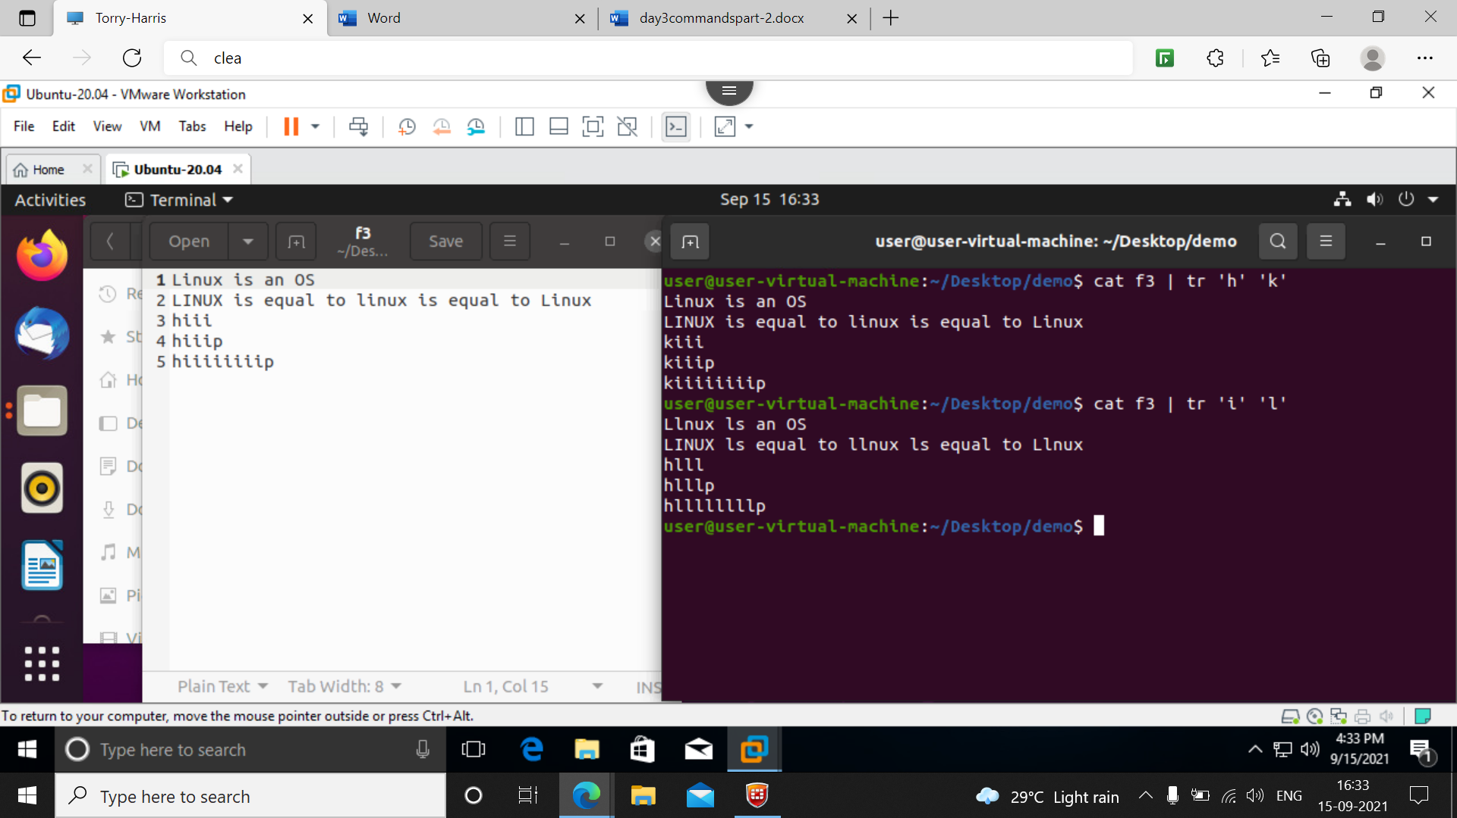

**47] cat f3 | tr –s [:space:] ‘ ‘**

This command tells in f3 if the data has too many spaces to squeeze the data we use –s here

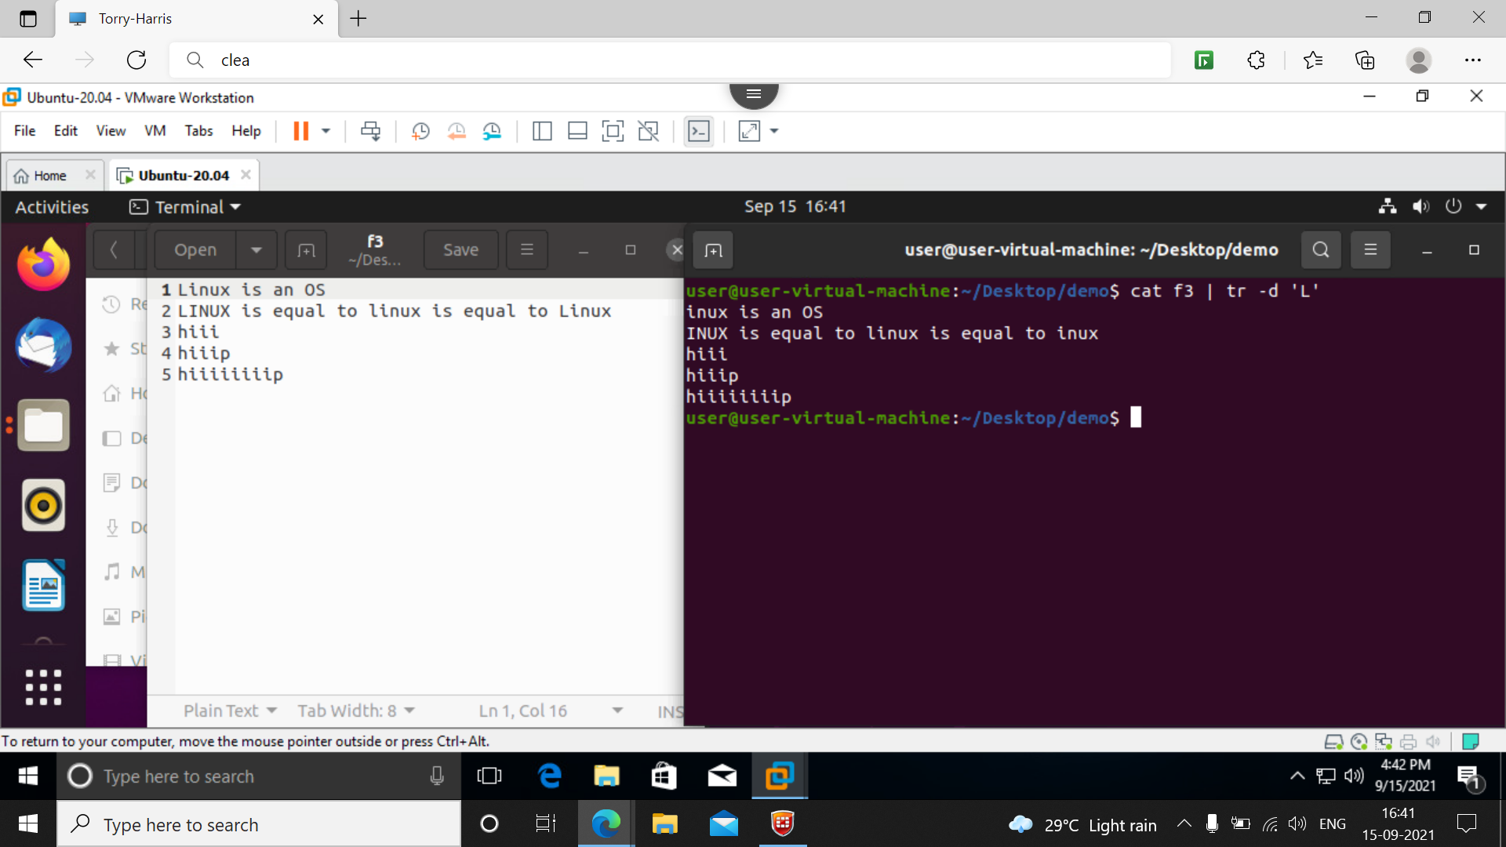

**48] cat f3 | tr –d ‘L’**

Here –d is used to delete the given character

Here ‘L’ is deleted from the f3 file

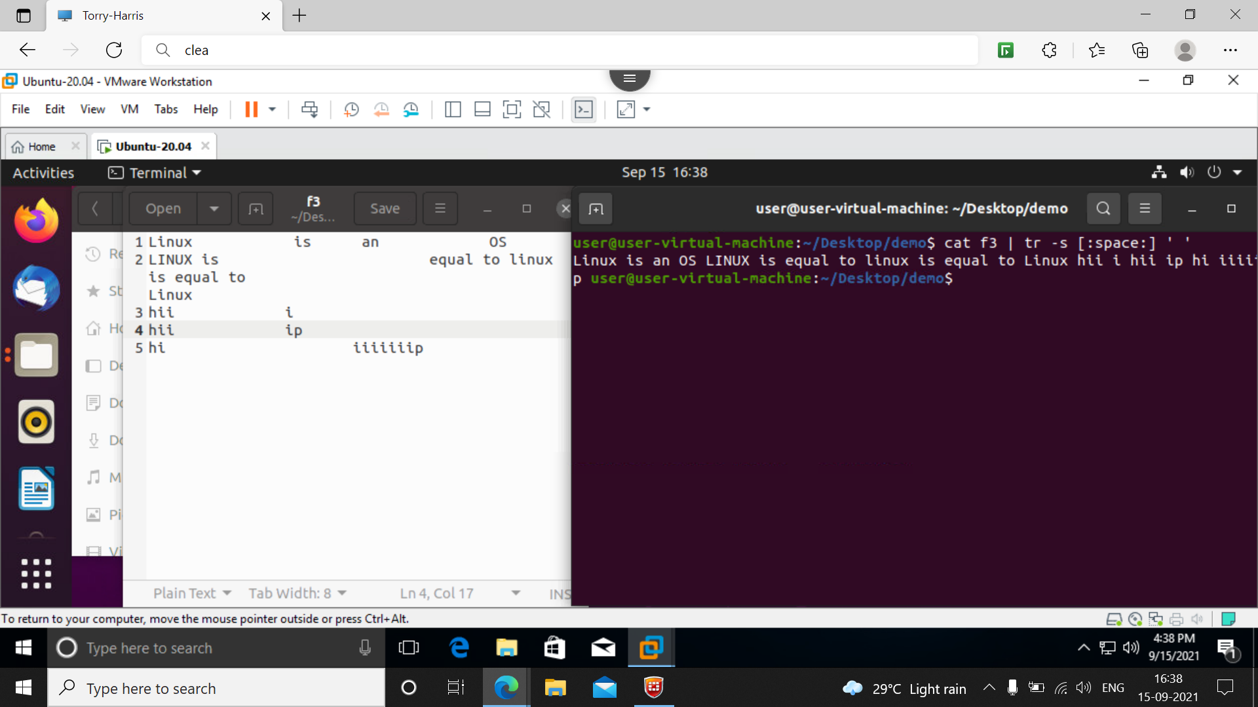

49] **cat f3 | tr –d ‘[:upper:][:digit:]’**

This command removes the upper and digits from the file we want

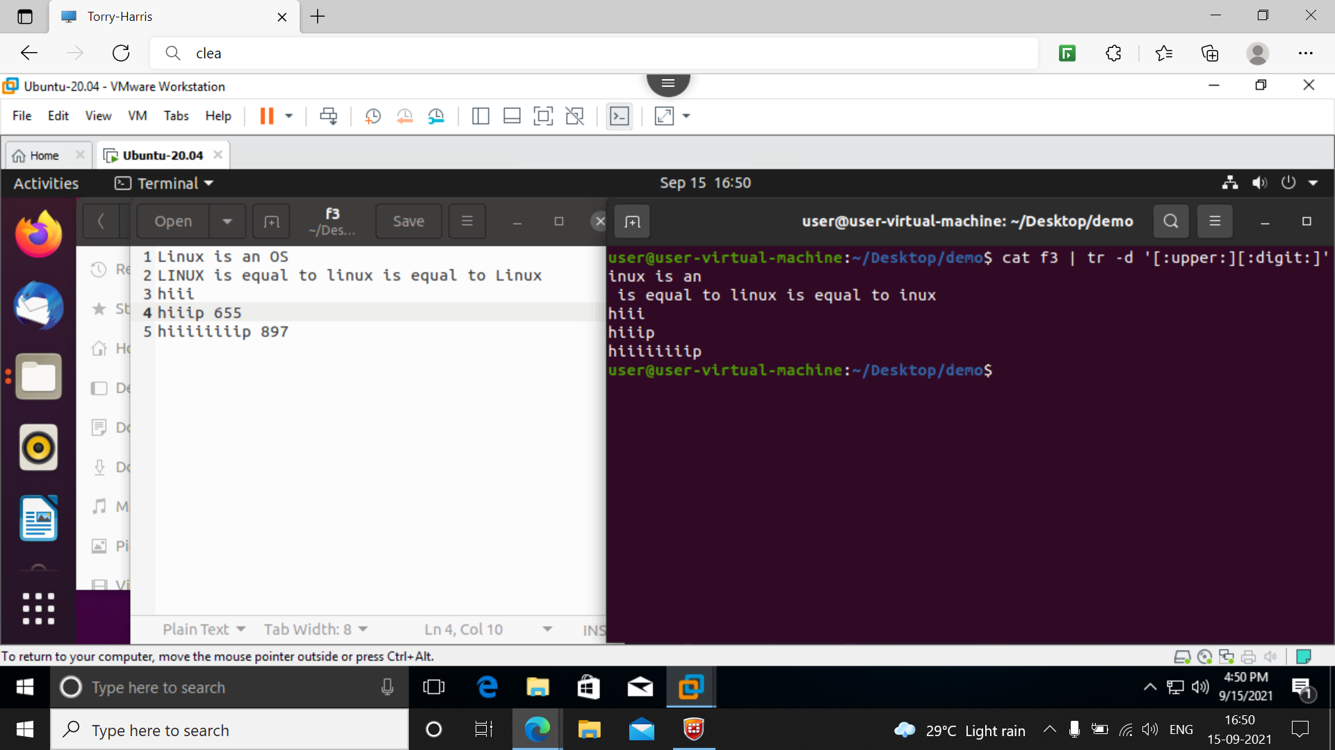

**50] more**

More filename -- syntax

The data will be displayed we can use space bar to see full dta, enter to see line by line and ‘b’ to go back

